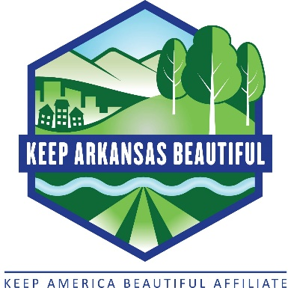  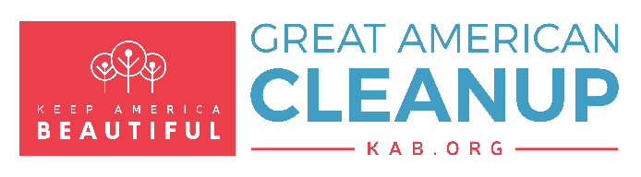 | News  For Immediate Release  Information Contact:  Your Name, Cleanup Coordinator  Group Name  Your Phone Number  Your Email Address

Community/County/City Name community litter-pickup event set for Date

Volunteers needed to help keep Community/County Name beautiful

COMMUNITY NAME (Date of Release) – Volunteers are needed to participate in Group Name’s spring community improvement event Date and Time of Cleanup. The cleanup is being held in conjunction with the Keep America Beautiful Great American Cleanup in Arkansas (GAmC), the annual spring statewide litter-pickup campaign promoted by Keep Arkansas Beautiful (KAB).

“So much can be accomplished when we work together to keep Community/County Name beautiful,” said Your Name of Your Hometown, local coordinator of this year’s cleanup. “Litter can leave a negative impact on our community for years to come. By participating in this year’s Great American Cleanup in Arkansas, local residents can help make Community/County Name a vibrant community.”

Everyone in Community/County Name is encouraged to participate in this year’s community improvement effort. Civic and service organizations, church and youth groups, school groups and clubs, scouts, individuals, families, neighborhoods, and businesses can organize cleanup teams and pitch in.

Paragraph detailing when and where volunteers should meet and sign in on day of cleanup. Be sure to identify the specific areas of the community that will be picked up. Also be sure to mention any supplies, such as trash bags, that you’ll be distributing to volunteers or items volunteers are encouraged to bring themselves, such as work gloves.

About the Great American Cleanup

The kickoff for the Keep America Beautiful Great American Cleanup in Arkansas is March 1. Local Great American Cleanup events are being organized in March, April and May. Activities will include beautifying parks and recreation areas, cleaning waterways, collecting recyclables, picking up litter, planting trees and flowers, and conducting educational programs and litter-free events.

Last year, 166 litter-pickup and beautification events took place statewide. Nearly 135,000 pounds of litter was collected from Arkansas’ roadways, waterways and parks.
About Keep Arkansas Beautiful
The Keep Arkansas Beautiful Commission (KAB), consisting of a professional staff and a nine-member advisory board appointed by the governor, is a division of the Arkansas Department of Parks and Tourism. As a certified state affiliate of Keep America Beautiful Inc., KAB inspires and educates individuals to reduce litter, recycle and keep Arkansas beautiful. KAB is funded through its 1 percent portion of the eighth-cent Conservation Tax and, by mobilizing volunteers, returns to the state a cost benefit of more than $6 in community service for each program dollar spent. For more information, visit KeepArkansasBeautiful.com or stay connected on Facebook, Twitter, Instagram and YouTube.

About Keep America Beautiful, Inc.
Keep America Beautiful is the nation’s premier community improvement organization. Founded in 1953, the nonprofit has a network of affiliates around the U.S. focused on litter prevention, waste reduction and beautification. Keep America Beautiful is recognized as the leader in changing attitudes and behaviors affecting our community environments. Through its actions, Keep America Beautiful helps create communities that are socially connected, environmentally healthy and economically sound. Today, it continues to be the most credible organization in its three focus areas by vigorously pursuing its guiding principles of education, volunteerism, partnership and individual responsibility. For more information, visit kab.org.

-30-

